DESIGN ANALYSIS AND ALGORITHM
ASSIGNMENT -3

V.GOVARSHAN
CH.SC.U4CSE24210

BREATH FIRST SEARCH (BFS)

CODE:
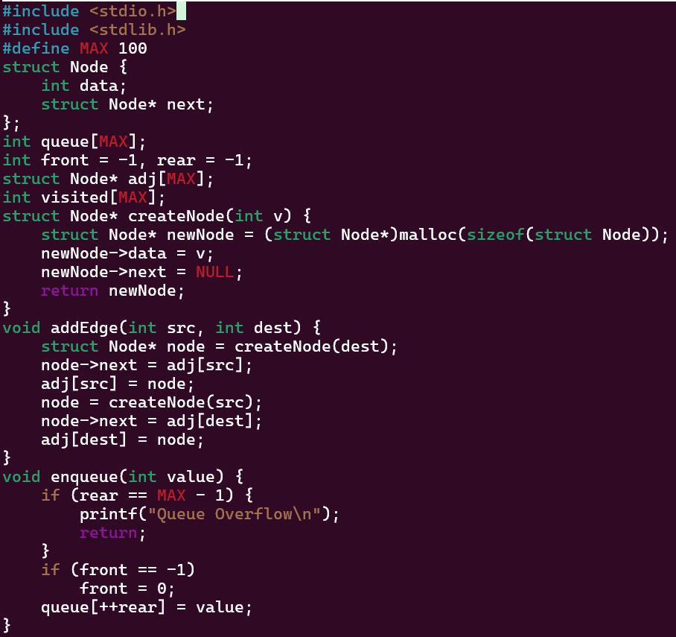
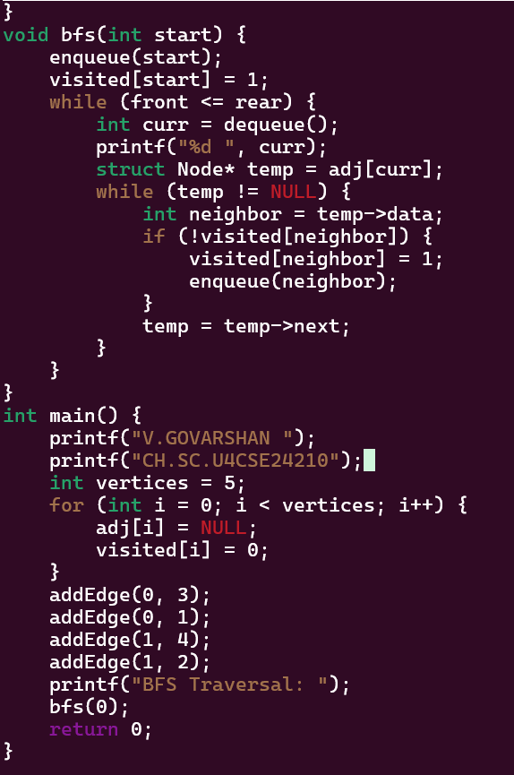

OUTPUT
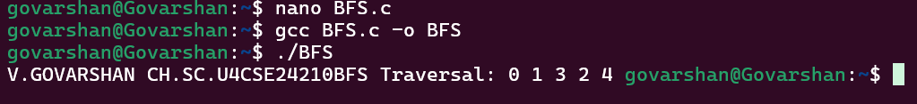

INTERPERATION:
- Start from a source vertex
- Mark it as visited
- Insert it into a queue
- While the queue is not empty:

  - Remove the front vertex
  - Visit all its unvisited adjacent vertices
  - Mark them visited
  - Insert them into the queue

DEPTH FIRST SEARCH (DFS):
CODE:
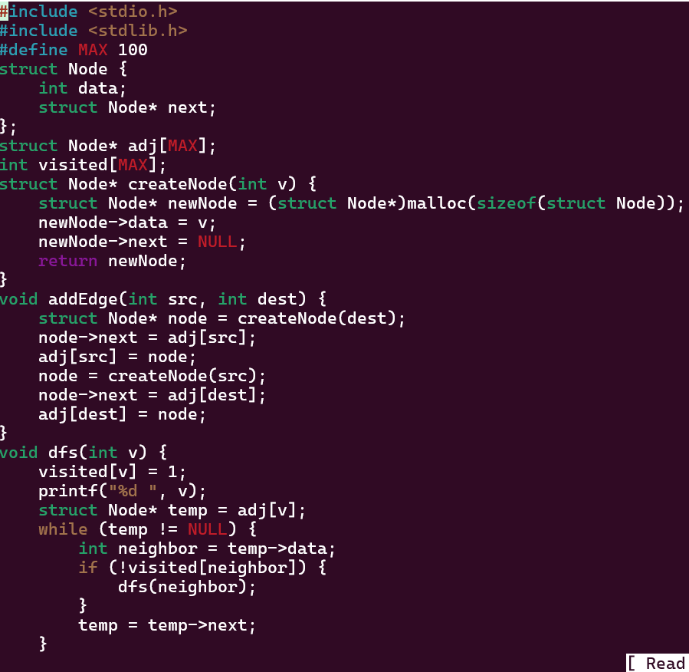
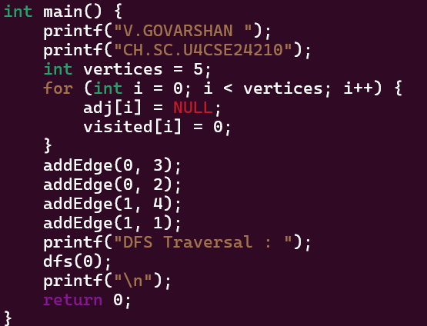
OUTPUT:
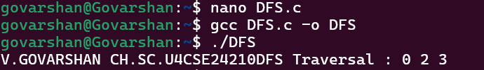

INTERPERATION:
- Start from a given source vertex
- Mark the vertex as visited
- Visit one unvisited adjacent vertex
- Repeat the process recursively for that vertex
- When no unvisited neighbors remain, backtrack to the previous vertex

